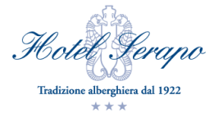
Fq13 2017

Reservation form

Title …..................Name …....................................Surname........................................................

Address ….....................................................................................................................................

Town.............................................................. Country ….............................................................

Arrival day …......................... Departure day…....................................

Number of accompanying people (where applicable) …..................................

Conditions as listed below apply only if requested via this dedicated form by April 30.
Prices are per person per day, include breakfast and dinner (with water and wine) and refer to a minimum stay of 2 nights.

Single (Double single use) □ Double □ Triple □
€ 74 € 62 € 58

Room to share with (where applicable) ..............................................................................................

….....................................................................................................................................................
Note: this part of the form, if filled, is valid as reservation for all the room occupants, i.e., participants or accompanying people listed above do not need to send their own reservation form

Special meal requests

Vegetarian □ Vegan □ Celiac □

Other (specify) …...............................................................

